CAI - APPOINTMENT OF NEW OFFICE BEARERS
FOR THE YEAR 2023-24
------------------------------------------------------------------------------------
At the meeting of the Cotton Association of India’s Board of Directors held on 27th December 2023, the following office bearers have been appointed for the year 2023-2024:-

Shri Atul S. Ganatra, President
Shri Bhupendra Singh Rajpal, Vice-President
Shri Vinay N. Kotak, Addl. Vice-President
Shri Arun Sekhsaria, Executive Addl Vice President
Shri Shyamsunder M. Makharia, Hon.Treasurer
Shri Rintu K. Pandya, Hon. Additional Treasurer

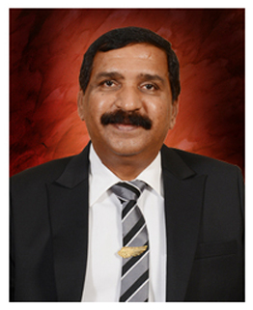  Atul S. Ganatra,  President | 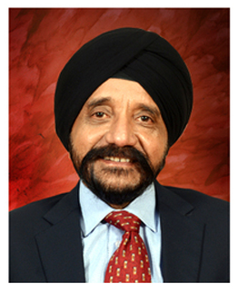  Bhupendra Singh Rajpal, Vice-President | 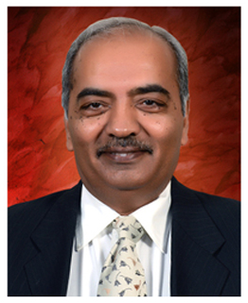  Vinay N. Kotak  Addl. Vice-President
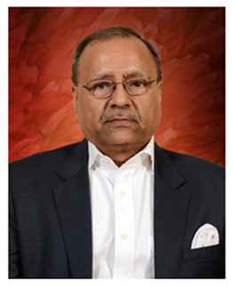  Arun Sekhsaria, Executive Addl Vice- President | 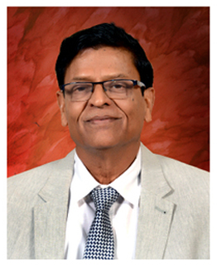  Shyamsunder M. Makharia, Hon.Treasurer | 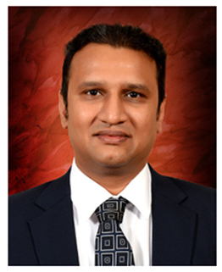  Rintu K. Pandya, Hon.Additional Treasurer

