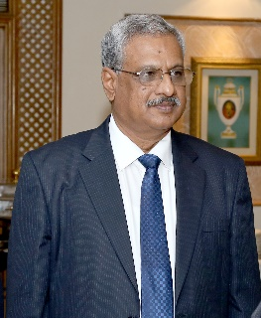

Mr. Sankar M, President, Lakshmi Machine Works Ltd., (Textile Machinery Division (LMW TMD), Coimbatore has been elected as the Chairman of Textile Machinery Manufacturer’s Association (India) (TMMA) for the year 2023-2024.

Mr. Sankar is a seasoned professional with a rich experience of over 40 years in Textile Industry. A Textile Engineer from Madras University Chennai, he has been associated with LMW Textile Machinery Division since last 36 years. His long and distinguished service at LMW made significant contribution to the textile industry in general.
He has also served as Chairman of LMW Textile Machinery (Suzhou) Co. Ltd, China; a wholly owned subsidiary of LMW for a span of 4 years.
A former member of CII’s Textile Sub Committee, Mr. Sankar brings with him a unique perspective of having seen from inside, India’s textile and textile machinery sector grow from a conservative sector to one of the leading adopters of technology to meet dynamic needs of Indian and global customers.
With decades of experience in Strategic Management, Sales and Marketing, Mr. Sankar is an expert in bringing together diverse elements like R&D, Supply Chain and Quality into delivering best value to customers thereby transforming LMW TMD into a preferred supplier of state-of-the-art textile machinery worldwide.

